SRS-DLD

S/W Detailed Level Design

Project Name | Railway Ticket System
Course | ICS0017
Author | Turks D. | Approver | Kyselova A.
Team | Team 11

Contents

1. Overview 4
Scope 4
Main Objectives 4
Role of This Document 4
System Context 5
Key Stakeholders and User Roles 5
1. System Overview / Architectural Context 6
2. UML Class Diagram (Technical Design) 7
3. Class Specifications 7
5. Interfaces and Abstractions 10
6. Function Responsibilities 11
7. Operation Flow 14
Operational Flow (Release 2) 17
8. Enumerations & Constants 17
9. Validation Rules & Future Work 18
10. Traceability Matrix 20
11. Code Structure and File Mapping 22
12. Revision History 22
13. Validation Rules & Preconditions/Postconditions 23
14. Behavioral Models 25
Activity Diagram 25
Sequence Diagram 27
15. Error & Exception Handling Policy 28
16. Revision History 29

- Revision History
Version | Date | Revised contents | Author | Approver
1.0 | 2025-10-28 | Release 2 DLD | Turks D. | Kyselova A.
2.0 | 2025-11-24 | Release 3 DLD | Turks D. | Kyselova A.
3.0 | 2025-12-15 | Release 4 DLD | Turks D. | Kyselova A.
- References
- Requirements Specification

1. Overview
The Railway Ticket Sales System is designed to automate and streamline ticket-related operations for railway services, including ticket purchasing, refund processing, and daily reporting. Its primary purpose is to eliminate manual inefficiencies such as double bookings, calculation errors, and delayed reporting, thereby improving accuracy, speed, and reliability in ticket management.

Scope
The system is implemented as a host-based, single-user C++ application operating in a command-line interface (CLI) environment. It supports:
- Ticket search by date, destination, and optionally coach type
- Reservation and release of tickets during purchase flow
- Refund processing with penalty calculation based on predefined business rules
- Daily report generation for sold and refunded tickets
- Persistent storage of ticket history using file-based mechanisms
Excluded from the current scope are online payment integration, real-time ticketing APIs, multi-user concurrency, and database-backed persistence (planned for future releases).

Main Objectives
- Provide a robust and user-friendly solution for ticket sales and returns.
- Ensure accurate application of refund penalties and profit calculations.
- Maintain operational consistency across supported platforms (Windows and Linux).
- Enable modular design for future enhancements such as durable persistence and advanced reporting.

Role of This Document
This document serves as a reference for system context and design intent. It defines:
- The architectural principles (three-layer structure: UI, Logic, Data)
- Key classes, interfaces, and their responsibilities
- Traceability between requirements and design components
It ensures alignment between functional requirements and technical implementation, supporting maintainability and scalability.

System Context
The system operates in an offline environment on local machines without internet dependency. It interacts with users through a CLI-based interface and stores operational data in local files (CSV/TXT). The architecture enforces separation of concerns. The presentation layer (ConsoleUI) – handles user interaction and input/output formatting. The logic layer (TicketService) implements business rules, refund logic, and transaction orchestration. Lastly, the data layer (Repositories) manages in-memory ticket and passenger records, with planned migration to persistent storage.

Key Stakeholders and User Roles
- End-users purchasing or returning tickets – clients
- Operators managing ticket transactions and assisting clients – cashiers
- Supervisors reviewing daily reports and monitoring operational efficiency – Central Office managers
- Responsible for implementing, maintaining, and extending the system – system developers

System Overview / Architectural Context
Architecture follows a three-layer structure with one-way dependencies (UI Logic Data):
- Presentation Layer (UI): ConsoleUI – responsible only for user interaction, input parsing, and textual output; it translates user actions into service calls and displays results or errors, it does not implement business rules or access storage directly.
- Logic Layer (Business): TicketService, IClock, Employee abstractions, utility helpers – contains domain rules and flows (search reserve purchase return), refund and profit calculations, transaction registry, and orchestration of repository updates; depends on abstractions (IClock, repository interfaces) rather than concrete storage.
- Data Layer (Storage): TicketRepository, PassengerRepository, TrainRepository (stub) – in-memory storage and query/update primitives (add, find, getById, updateStatus, adjustBalance); persistence is intentionally deferred to a separate Persistence module (CSV/DB) in a later release.
Design principles: Separation of Concerns, Single Responsibility, Dependency Inversion (low coupling via small interfaces). UI never mutates repository state directly; Data layer never performs presentation; business logic is isolated for testability and deterministic unit tests. Main.cpp only wires components, seeds sample data, and hands control to ConsoleUI.
Release 4 Extension – Persistent Storage Lifecycle
Release 4 extends the architecture with persistent file storage while preserving the three-layer structure. Repositories now manage two synchronized storage models: in-memory collections and persistent CSV files. During application startup, repositories load and validate file contents into memory. During shutdown or auto-save, in-memory state is serialized back to files. File I/O errors or malformed data do not propagate as exceptions; instead, invalid lines are skipped to protect in-memory consistency.

UML Class Diagram (Technical Design)
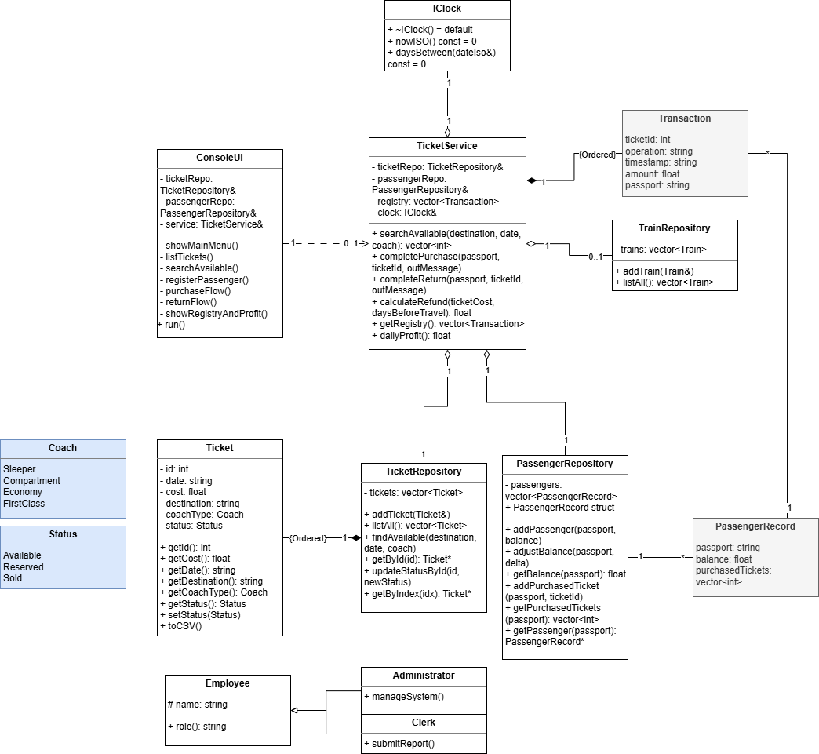
Repository classes are extended with persistence-related operations:
- loadAll(path)
- saveAll(path)
- parseLine(line)
- toLine(object)
No new classes or relationships are introduced.

Class Specifications
Class | Type | Description | Attributes | Methods
ConsoleUI | UI | Console interaction and formatting; prompts and renders results | mTicketRepo; mPassengerRepo; mService | displayMenu(); run(); listTickets(); searchAvailable(); registerPassenger(); purchaseFlow(); returnFlow(); showRegistryAndProfit()
TicketService | Service | Coordinates search, reserve, purchase, return flows; refund and profit logic; transaction registry | mTicketRepo; mPassengerRepo; mRegistry; mClock | TicketService(...); searchAvailable(destination,date,coach); completePurchase(passport,ticketId,outMessage); completeReturn(passport,ticketId,outMessage); calculateRefund(cost,daysBefore); getRegistry(); dailyProfit()
Ticket | Domain model | Ticket identity, booking state and CSV serialization | mId; mDate; mCost; mDestination; mCoachType; mStatus | Ticket(...); getId(); getDate(); getCost(); getDestination(); getCoachType(); getStatus(); setStatus(Status); showDetails(); toCSV()
Types / Enums | Utility | Enums and human-readable converters used across UI and services | enum Status; enum Coach | StatusToString(Status); CoachToString(Coach)
Transaction | DTO | Registry record for purchases and returns | ticketId; operation; timestamp; amount | (aggregate data only; no methods)
IClock | Interface | Abstract time source to decouple date logic and enable deterministic tests | - | nowISO(); daysBetween(dateIso)
SimpleClock (factory) | Concrete | Default IClock implementation and factory makeSimpleClock() | - | nowISO(); daysBetween(dateIso); makeSimpleClock()
TicketRepository | Repository | In-memory storage and query/update primitives for tickets | mTickets | addTicket(const Ticket&);  listAll() const  findAvailable(destination, date, coachFilter) -> vector<int>;  getById(id) -> Ticket*;  getByIndex(index) -> Ticket;  updateStatusById(id, newStatus) -> bool;  loadAll(path);  saveAll(path);  parseLine(line);  toLine(ticket)
PassengerRepository | Repository | In-memory passenger records: balances and purchased tickets | mPassengers (PassengerRecord: passport,balance,purchasedTickets) | addPassenger(passport,balance); getPassenger(passport) -> PassengerRecord*; adjustBalance(passport,delta) -> bool; getBalance(passport) const; addPurchasedTicket(passport,ticketId); getPurchasedTickets(passport) const
TrainRepository | Repository (stub) | Placeholder for train/schedule data | - | addTrain(trainId)
Employee | Demo role | Simple inheritance demo for wiring and roles | mName | Employee(name); virtual role() const = 0; name() const
Clerk | Demo role | Concrete employee role used in startup wiring | (inherited) | Clerk(name); role() const override
Administrator | Demo role | Concrete employee role used in startup wiring | (inherited) | Administrator(name); role() const override
Util | Utility | Small helpers for timestamps and monetary rounding | - | nowTimestamp(); round2(float)

5. Interfaces and Abstractions
Interface | Purpose | Key Methods | Planned For (Release)
IClock | Decouple system time for deterministic logic and testing | nowISO(); daysBetween(dateIso) | 2
TicketService (service boundary) | Facade for domain operations; coordinates repositories, time source, and business rules | searchAvailable(dest,date,coach); completePurchase(passport,ticketId,outMsg); completeReturn(passport,ticketId,outMsg); calculateRefund(cost,daysBefore) | 2
Repository abstractions (IRepository<T> planned) | Abstract data access to allow swapping in persistent stores and fakes for tests | get(id); save(T); list() -> std::vector<T> | 3
IExchangeOperation (planned) | Enable polymorphic exchange/processing behaviors (fees, channels) | processExchange(amount,from,to,rate) -> double | 3
ReportService / IReportable (planned) | Standardize report generation from domain state and allow interchangeable report generators | buildDailyReport(balances,profit); (IReportable) generate() -> Report | 2 (ReportService implemented); 3 (IReportable)
Interface | Purpose | Key Methods | Planned For (Release)

6. Function Responsibilities
Class | Method | Purpose | Input | Output | Notes
TicketService | searchAvailable | Query repository for matching available tickets | destination (string), date (ISO string), coachFilter (optional Coach) | vector<int> (ticket IDs or indices) | Read-only; no state mutation; filters Status::Available.
TicketService | completePurchase | Validate passenger and balance, charge, mark ticket sold, record transaction | passport (string), ticketId (int), outMessage (string& for user) | bool (success) | Adjusts PassengerRepository balance, updates Ticket status, appends Transaction to registry; returns descriptive outMessage on failure.
TicketService | completeReturn | Validate ownership and refund window, compute refund, credit passenger, mark ticket available, record transaction | passport (string), ticketId (int), outMessage (string& for user) | bool (success) | Uses IClock.daysBetween to determine refund bracket; calls calculateRefund; enforces service invariants.
TicketService | calculateRefund | Deterministic refund computation and rounding | ticketCost (float), daysBefore (int) | float (refund amount) | Pure function; uses Util::round2 for two-decimal monetary rounding.
TicketService | getRegistry / dailyProfit | Expose transaction history and aggregate profit | - | vector<Transaction> / float | Read-only views of session registry used by reporting and tests.
TicketRepository | addTicket / listAll | Store and enumerate tickets in memory | Ticket | void / vector<Ticket> | In-memory only in R2; no persistence; append semantics.
TicketRepository | findAvailable | Locate available tickets matching criteria | destination, date, optional coach | vector<int> (IDs/indices) | Returns candidates for UI selection.
TicketRepository | getById / updateStatusById | Lookup and mutate ticket state | id (int) / (id, Status) | Ticket* / bool | Minimal bounds checking; business validation kept in TicketService.
PassengerRepository | addPassenger / getPassenger | Manage passenger records and balances | passport (string), balance (float) | void / PassengerRecord* | In-memory store for balances and purchased ticket list.
PassengerRepository | adjustBalance / addPurchasedTicket | Change balance and record ownership | passport, delta / passport, ticketId | bool / void | adjustBalance enforces non-negative balance semantics in R2 basic guard.
IClock (SimpleClock) | nowISO / daysBetween | Provide current timestamp and date arithmetic | — / dateIso (string) | string (ISO) / int (days) | Injected into TicketService to make time-dependent rules testable and deterministic.
ConsoleUI | run / purchaseFlow / returnFlow / showResult | Present menu, collect input, and display results | user input via console | printed output; return codes | Performs only syntactic validation; delegates business rules to TicketService; uses repository methods for read-only listing.
Util | nowTimestamp / round2 | Provide canonical timestamp and monetary rounding | - / float value | string / float | Shared helpers used by service and transaction timestamping.
ReportService | buildDailyReport | Aggregate balances and profit into Report DTO | balances (map<Currency,double>), profit (double) | Report | Pure aggregation; formatting delegated to ConsoleUI. Implemented as concrete service in R2.
Employee / Clerk / Administrator | constructors / role / name | Lightweight role objects for wiring and demo | name (string) | role string / name string | Demo-only; no authorization logic; used in startup wiring and examples.
Class | Method | Purpose | Input | Output | Notes

7. Operation Flow
Step 1 – User interaction (Presentation)
- ConsoleUI displays the main menu and prompts the user for an action (list, search, purchase, return, show registry).
- ConsoleUI performs only basic syntactic checks (non-empty inputs, numeric parsing) and translates raw input into typed parameters (passport, ticketId, date, coach, amount).
- ConsoleUI calls the service boundary (TicketService) with the validated parameters.
Step 2 – Service delegation (Logic)
- ConsoleUI invokes TicketService methods (searchAvailable, completePurchase, completeReturn, getRegistry) to execute user intent.
- TicketService is the orchestrator for domain flows; it does not perform console I/O.
Step 3 – Lookups and preconditions
- TicketService queries TicketRepository for candidate tickets (findAvailable / getById) and PassengerRepository for passenger records (getPassenger).
- TicketService verifies structural preconditions (ticket exists, status is Available/Reserved/Sold, passenger exists).
Step 4 – Time-dependent checks
- When a flow requires date logic (refund eligibility, refund amount), TicketService calls IClock.daysBetween or nowISO to compute days-to-travel and timestamp transactions.
- IClock is injected, enabling deterministic behavior in tests.
Step 5 – Business decision and computation
- For purchases: TicketService computes costs, checks passenger balance, and determines side effects (charge amount).
- For returns: TicketService computes refund via calculateRefund(ticketCost, daysBefore) and rounds with Util::round2.
- All business rules (ownership checks, refund bracket, penalty) are encoded in TicketService.
Step 6 – State mutation (Data)
- TicketService requests repository operations to persist state changes: PassengerRepository.adjustBalance, PassengerRepository.addPurchasedTicket, TicketRepository.updateStatusById.
- Repositories implement in-memory updates and basic guards; they do not perform business validation beyond structural checks.
Step 7 – Registry, profit and reporting
- TicketService appends a Transaction record to its in-memory registry for each completed operation.
- TicketService exposes dailyProfit() and getRegistry() for reporting.
- ReportService (concrete) consumes the aggregated balances and profit to produce a Report DTO (buildDailyReport). Formatting and presentation of the report is done by ConsoleUI.
Step 8 – Presentation of outcome
- ConsoleUI receives results and outMessages from TicketService and prints:
  - confirmation or error messages
  - updated ticket lists or balances
  - the daily report (Report.toString) when requested
- ConsoleUI remains presentation-only and never mutates domain state directly.
Future work: introduce durable persistence (IRepository<T> implementations and FileService/DB), comprehensive validation and exception handling, configurable alerts and thresholds, a polymorphic IExchangeOperation for fee/channel strategies, formal sequence/state diagrams, and CI-backed integration tests to verify end-to-end persistence and error recovery.

Operational Flow (Release 2)
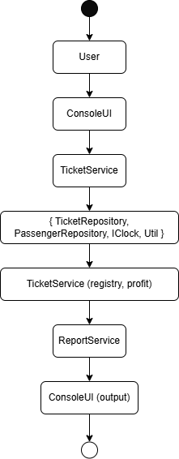

8. Enumerations & Constants
Name | Value / Type | Description
enum class Status | { Available, Reserved, Sold } | Ticket lifecycle states used by Ticket and repositories.
enum class Coach | { Sleeper, Compartment, Economy, FirstClass } | Coach categories used for filtering and display.
const int ROUNDING_SCALE | 2 | Decimal places for monetary rounding; used by Util::round2 to keep two-decimal precision.
const char REPORT_DATE_FMT* | "YYYY-MM-DD" | Canonical date format for timestamps and report headers.
const float MIN_BALANCE | 0.0 | Lower bound for passenger balances; repositories prevent negative balances in R2 (basic guard).
const int REFUND_FULL_DAYS | 30 | Days-before threshold for full refund (used by TicketService refund logic).
const int REFUND_PARTIAL_DAYS | 7 | Days-before threshold for reduced refund tier (used by TicketService).
const float REFUND_PARTIAL_RATE | 0.50 | Refund proportion for the partial refund tier (50% of ticket cost).
const float REFUND_NEAR_RATE | 0.00 | Refund proportion when returning within non-refundable window.

9. Validation Rules & Future Work
Rule / Planned Feature | Description | Target Release
Input validation | Validate user inputs and service parameters: amounts > 0, ISO date format, supported coach/currency values, valid ticket IDs and passport strings; return structured error codes/messages instead of boolean flags. | 3
Reserve / balance enforcement | Enforce pre-checks that block purchases exceeding passenger balance and prevent ticket state transitions that would create inconsistent reserves or duplicate ownership. | 3
Transactional atomicity | Make multi-step operations atomic: charge balance, update ticket status, and record transaction must succeed or roll back as a unit to avoid partial side effects. | Partial 3, full 4
Exception handling & error model | Introduce try/catch policies and a small error hierarchy; convert low-level errors into user-friendly messages at the UI boundary and structured errors for programmatic clients. | Partial 3, full 4
Durable persistence & IRepository<T> | Add FileService/DB-backed implementations and a generic IRepository<T> interface; migrate in-memory repositories to adapters that guarantee durability and versioned CSV/DB schema. | Partial 3, full 4
Sequence & state diagrams | Produce UML sequence and state diagrams for purchase/return flows, refund windows, and repository lifecycle to document runtime behavior and edge cases. | 3
Alerts, thresholds & monitoring | Implement configurable thresholds and alerting for low balances or low ticket availability; surface warnings in UI and emit structured events for monitoring. | Partial 3, full 4
Validation policy engine | Centralize validation rules or use a small policy module so business rules (refund brackets, non-refundable windows) are data-driven and easier to test/tune. | Partial 3, full 4
Reporting persistence & audit trail | Persist transactions and daily reports with tamper-evident headers, exportable CSV lines, and search capability for audit and reconciliation. | Partial 3, full 4
Test coverage and CI | Expand unit tests for service boundaries and seam-based fakes, add integration tests exercising persistence, and gate changes with CI pipelines. | 3

10. Traceability Matrix
Requirement (SRS) | Class / Method (DLD) | Notes
Search for tickets by date, destination, coach type | TicketService::searchAvailable; TicketRepository::findAvailable | UI calls TicketService; repository returns Available tickets only.
Temporarily reserve tickets during purchase | TicketService::completePurchase (initial step); TicketRepository::updateStatusById (set Reserved) | Reservation is a service-level state transition; repository enforces state change.
Release tickets if purchase cancelled | TicketService (cancel path) ; TicketRepository::updateStatusById (set Available) | Service reverses side effects and updates ownership/purchased list.
Accept client passport information | ConsoleUI input TicketService::completePurchase / PassengerRepository::addPassenger | Passport stored in PassengerRepository record and linked to purchased ticket.
Issue tickets to client (mark Sold and assign) | TicketService::completePurchase; PassengerRepository::addPurchasedTicket; TicketRepository::updateStatusById (Sold) | TicketService performs checks, charges balance, records Transaction.
Automatically calculate penalties on returned tickets and refund client | TicketService::calculateRefund; TicketService::completeReturn; Util::round2 | Refund brackets encoded in calculateRefund; rounding via Util.
Mark refunded tickets as Available immediately | TicketService::completeReturn; TicketRepository::updateStatusById (Available) | Service updates status and ownership, appends Transaction.
Generate daily reports with profits and sold/refunded lists (to .txt/.csv) | ReportService::buildDailyReport; TicketService::getRegistry / dailyProfit; ConsoleUI (output & trigger) | ReportService builds DTO; persistence to .csv planned (R3).
Persist ticket data and history to files for retrieval on startup | Planned: IRepository<T>/FileService; Ticket::toCSV; Transaction serialization | Currently in-memory; concrete file-backed repositories and atomic I/O planned for R3.
All ticket operations logged into a file with timestamp | TicketService registry (Transaction with timestamp); Util::nowTimestamp; planned durable logging | Registry exists in-memory; file-based logs/atomic writes are R3 work.
Refund accuracy to two decimal places | TicketService::calculateRefund; Util::round2 | Implemented via round2 helper to meet rounding requirement.
Prevent double bookings / ensure consistency | TicketService validations + TicketRepository state checks | Business invariants enforced at service boundary; stronger atomicity/rollback planned for R3.
Daily reset to start workday with clean state | ConsoleUI/TicketService (operation) ; planned persistence reset behavior | In-memory reset trivial; persistent archival/reset behavior to be defined in R3.
Reject invalid input (passport format, negative balance) without crashing | ConsoleUI basic checks; TicketService validation (planned stronger) | CLI performs syntactic checks; structured validation and exception handling targeted for R3.
Atomic file writes to avoid database corruption | Planned: FileService with atomic write semantics (R3) | Not implemented in R2; explicitly targeted in Validation/Future Work.
Platform portability (Windows/Ubuntu) | Build/test wiring: CMake + portable C++ in headers/src | Code structured for cross-platform build; platform-specific I/O avoided.

11. Code Structure and File Mapping
Class / Module | Header (include/) | Source (src/)
ConsoleUI | include/ConsoleUI.h | src/ConsoleUI.cpp
TicketService | include/TicketService.h | src/TicketService.cpp
Ticket | include/Ticket.h | src/Ticket.cpp
Types / Enums | include/Types.h | src/Types.cpp
Transaction | include/Transaction.h | -
IClock | include/IClock.h | src/IClock.cpp
Util (rounding, timestamps) | include/Util.h | src/Util.cpp
PassengerRepository | include/Repositories.h | src/Repositories.cpp
TicketRepository | include/Repositories.h | src/Repositories.cpp
TrainRepository | include/Repositories.h | src/Repositories.cpp
Employee / Clerk / Administrator | include/Employee.h | src/Employee.cpp
Main | - | src/main.cpp

12. Revision History
Date | Version | Change Summary | Author
2025-10-28 | 1.0 | Release 2 DLD | Turks D.
2025-11-24 | 2.0 | Future work section updated to reflect implemented features in Release 3 and those which will be rolled over to Release 4 | Turks D.

13. Validation Rules & Preconditions/Postconditions
Class | Method | Preconditions | Postconditions | Validation Level | Explanation
ConsoleUI | registerPassenger | Passport string must be alphanumeric and ≥ 4 chars; balance input must parse to float and > 0 | Passenger added to repository with valid passport and positive balance | UI | UI ensures syntactic correctness before calling business logic
ConsoleUI | purchaseFlow | Passport and ticket ID must be valid formats (alphanumeric, positive integer) | Delegates to service; prints success or error message | UI | UI prevents invalid raw input from reaching logic layer
ConsoleUI | returnFlow | Passport and ticket ID must be valid formats | Delegates to service; prints success or error message | UI | UI ensures basic input correctness before service call
TicketService | completePurchase | Ticket exists and is Available; passenger exists; passenger balance ≥ ticket cost | Ticket status becomes Sold; passenger balance reduced; transaction recorded | Logic | Logic enforces business invariants and atomicity of multi-step operation
TicketService | completeReturn | Ticket exists and is Sold; passenger owns ticket; travel date valid | Ticket status becomes Available; refund credited; transaction recorded | Logic | Logic applies refund rules and ownership checks
TicketService | calculateRefund | Ticket cost ≥ 0; daysBeforeTravel ≥ 0 | Returns refund amount rounded to two decimals | Logic | Logic centralizes deterministic refund computation
TicketRepository | updateStatusById | Ticket ID exists in repository | Ticket status updated to new value | Repository | Repository enforces structural integrity of stored data
PassengerRepository | adjustBalance | Passenger exists; resulting balance ≥ 0 | Passenger balance updated | Repository | Repository prevents negative balances to maintain data consistency
PassengerRepository | addPassenger | Passport unique in repository | Passenger record created with initial balance | Repository | Repository ensures uniqueness and structural correctness

14. Behavioral Models

Activity Diagram
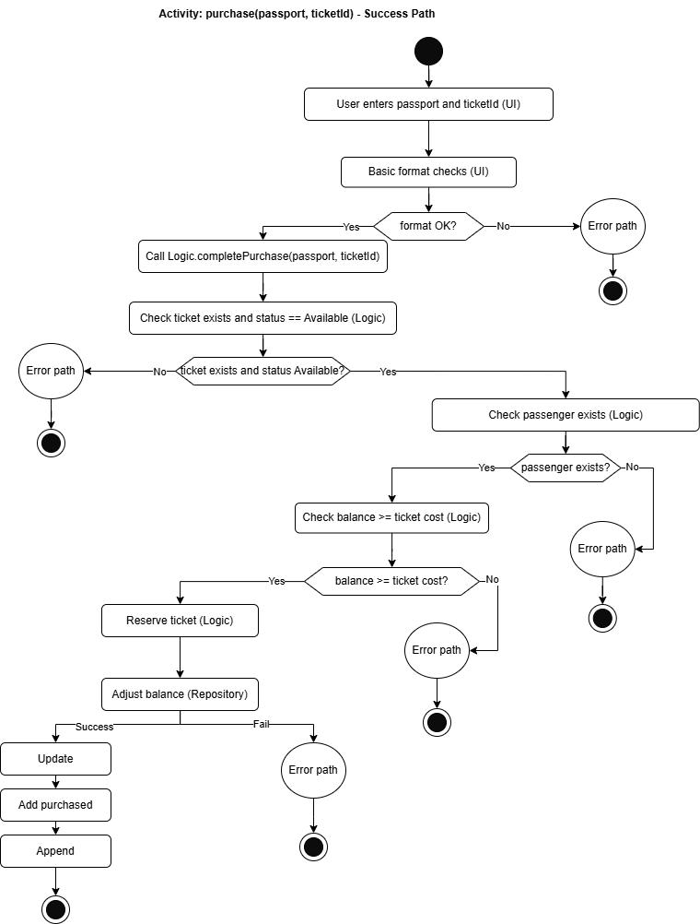

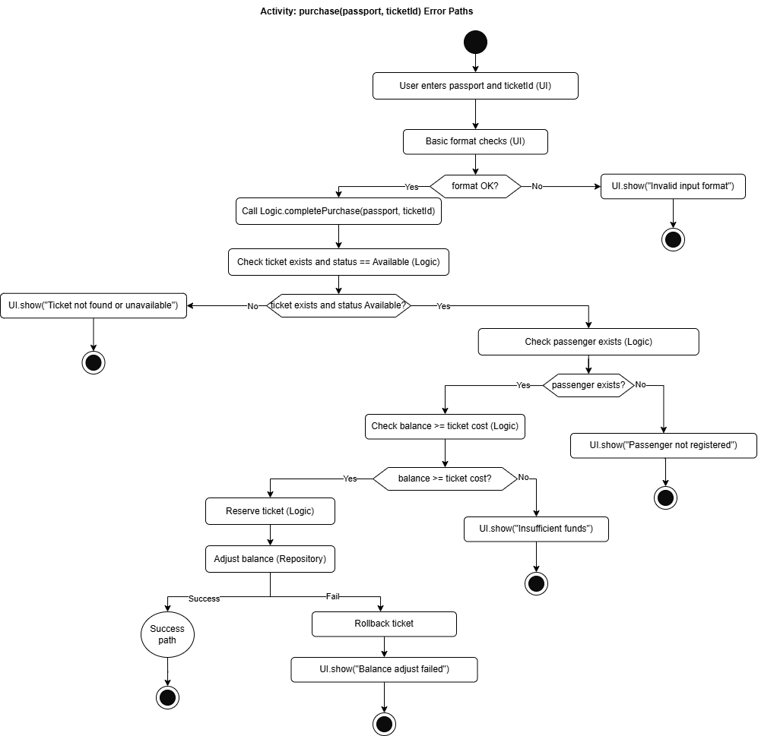

Sequence Diagram
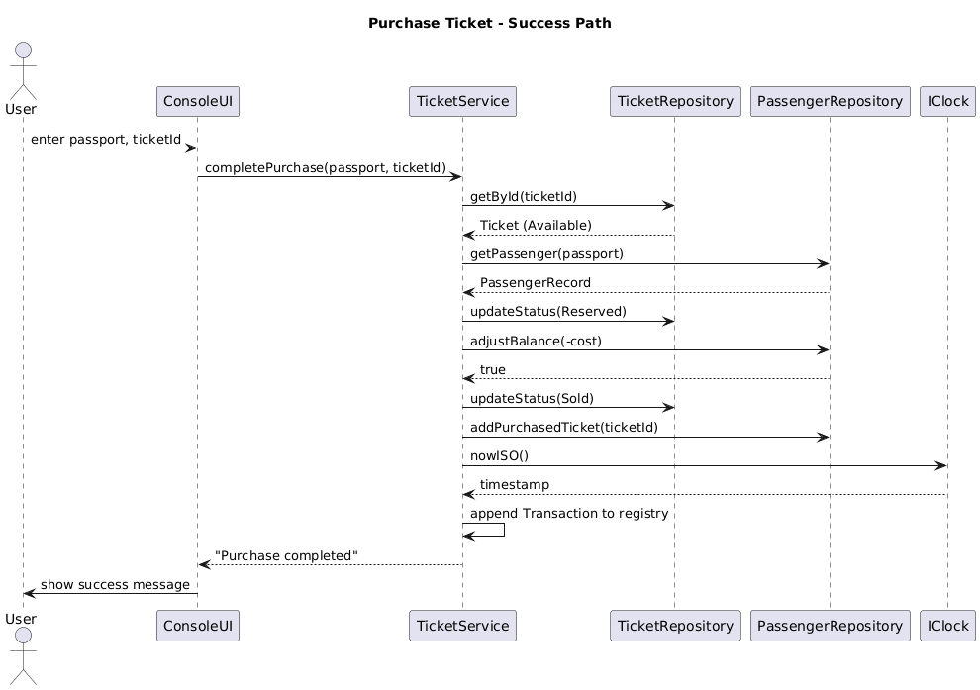
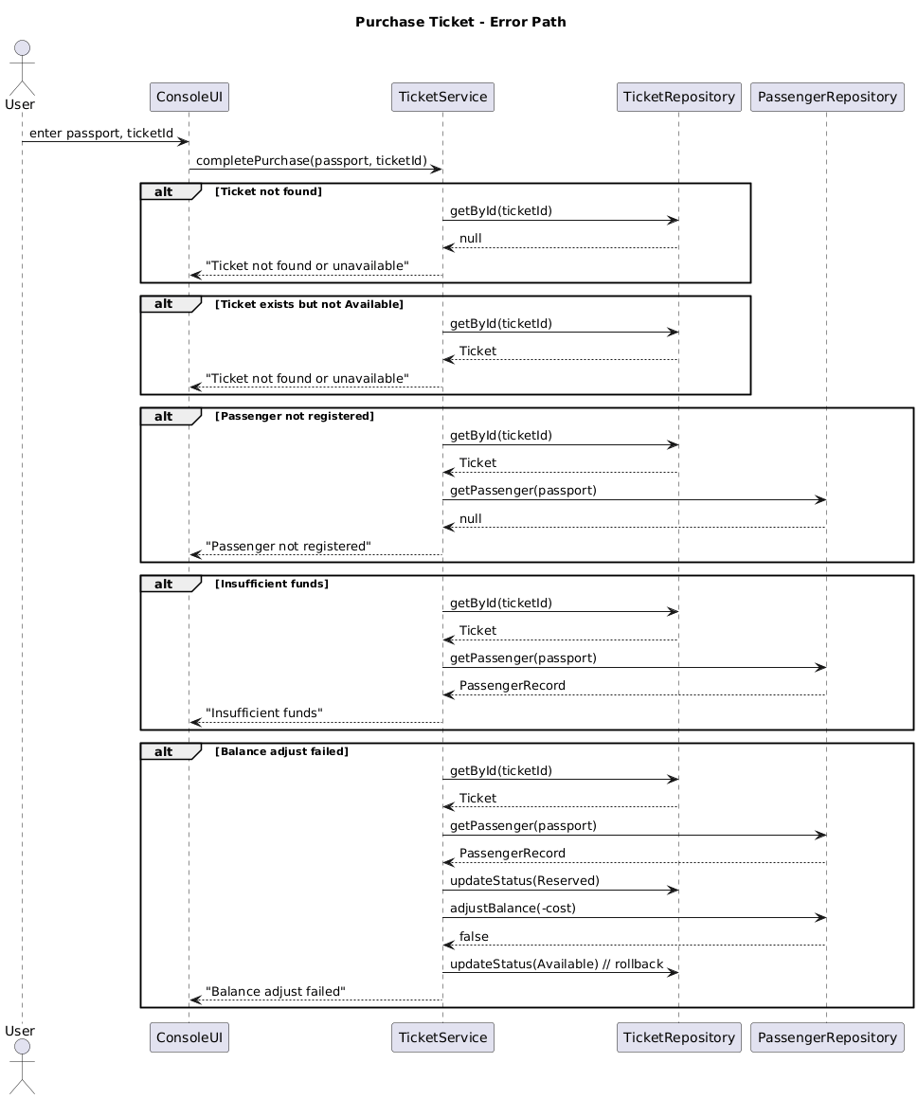

15. Error & Exception Handling Policy
Exception Type | Thrown By | Caught At | Message / what() | Default Action
ValidationException | UI / ConsoleUI (input parsing) | UI | "Invalid input format" / "Amount must be greater than zero" | Show message, stop current flow
std::invalid_argument | Logic / Ticket constructor | Logic (during object creation) | "Ticket id must be positive" / "Date required" | Stop operation, log error
std::runtime_error | Logic / TicketService::completePurchase | Logic (internal try/catch) | "Passenger not registered" / "Insufficient funds" / "Balance adjust failed" | Rollback ticket status, return error message
RepositoryException | Repository / TicketRepository::save or PassengerRepository::save | UI (during auto-save callback) | "Cannot open file: " | Show message, continue (non-fatal)
RepositoryException | Repository / FileTicketRepository::load | UI (startup load) | "Cannot open file: " | Show message, fallback to defaults

16. Revision History

Date | Version | Change Summary | Author
2025-10-28 | 1.0 | Release 2 DLD | Turks D.
2025-11-24 | 2.0 | Release 3 DLD | Turks D.
2025-12-25 | 3.0 | Release 4 DLD | Turks D.

